Meta Description:
Your secret to running a successful email campaign lies in your understanding. Read this guide and be a pro to launch a successful campaign with ease.

Email Marketing: Your Guide to Launch a Successful Campaign
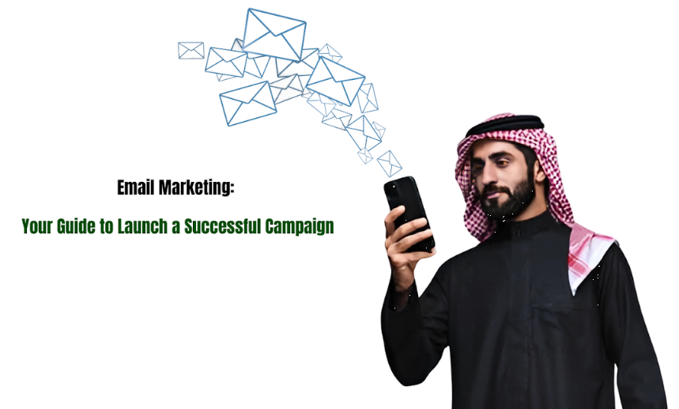
The first email was sent almost 54 years back in 1971.
From then to now email marketing has never seen a drop in terms of popularity.
No one can deny the role that email marketing is playing in the development and sales generation of brands.
Email marketing is an approach that remains extremely effective in an environment far beyond information-saturated.
Email marketing is not just yet another medium of conveying the message but it is a process full of activities deeply bound with data and analytics to influence and ascertain brand awareness, customer loyalty, and most importantly sales.
Email marketing, as a communication tool, can help marketers to reach people and amplify the voice of the brand whether you are a newbie or a veteran marketer.

What is Email Marketing?
Email marketing involves sending promotional newsletters or messages to different lists of subscribers through email. It is one of the oldest forms of digital marketing yet very effective and result-oriented.
Email marketing is a form of digital marketing that involves sending promotional messages or newsletters to a list of subscribers via email.
Unlike other forms of media which are social media advertising, search engine marketing, and content marketing, email marketing is typically a one-on-one type of marketing.

Differentiating Email Marketing from Other Digital Marketing Channels:
Here are different factors that you can use as a criterion to differentiate email marketing from other forms of digital marketing.

Direct Reach:
Email marketing offers the ability to directly communicate with your audience, unlike any other social networking site. In such digital channels, advertising messages are posted on the website and are viewed by the audience randomly.

Personalization:
Email marketing can be personalized easily without any kind of headache. Moreover, it is easy to subscribe to the specific type of content that possesses the most interest for the targeted users.

Permission-Based:
Unlike other forms of communicating with the client, email marketing requires the permission of the recipient to send the message.

Types of Email Marketing Campaigns:
Let’s talk about the different types of email campaigns you can come across.

Newsletters:
Informative updates that may come on a daily, weekly, or monthly basis can include information about your business or organization, and insights on your or the industry-related content. Newsletters help businesses build their audience’s trust and keep them informed.

Promotional emails:
Such emails include announcements, posted on the site invites, or appeals to cooperation, requests, newsletters, information, and updates on products’ availability or services.

Transactional Emails:
Automated responses to user actions, such as order confirmations or password resets, enhance user experience and engagement.

The Role of Email in the Marketing Mix:
Email marketing is associated with other promotional methods such as social media, and paid advertising. For example, social media can act as an audience builder for the email list, and email can lead the readers of a newsletter to subscribe to the social media content.

Benefits of Email Marketing for Lead Generation
- Email marketing is known to give high returns on investment, which makes it affordable to the businessman for lead generation.
- It Helps to Nurture Leads & Build Long Term Relationships.
- Third, it is helpful in long-term leads and customer relations because brands are likely to converse with customers when sending an email.

The Fundamentals of Email Marketing:
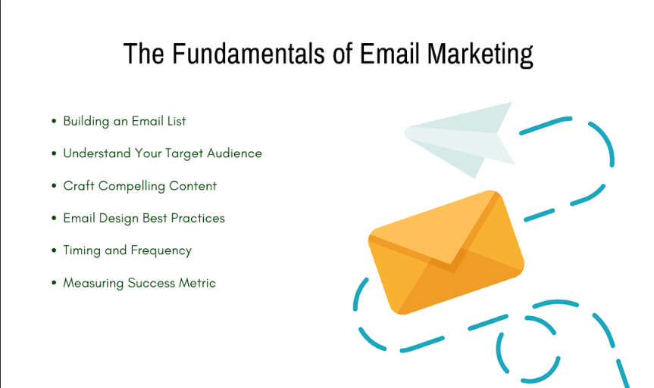

A. Building an Email List:
Here are some strategies for collecting subscribers ethically:
- Lead Magnets: These involve providing helpful content or offers of promotions for subscriptions to an organization or company’s mailing list.
- Signup Forms: Sure, the signup forms should be rather eye-catching, whether it is placed on the website, on social networks, or inside the app.
- Opt-in consent: For compliance with laws such as GDPR and CAN-SPAM, get the permission of the user.

Importance of Maintaining a Clean and Segmented List:

- List management: Always unsubscribe those who are inactive to enhance the reputation of your list.
- List Separation: It is an effective technique to divide your list based on customers' data to send them appropriate information.

B. Understand Your Target Audience:
The customer's understanding enables an organization to send more effective messages to the targeted audiences leading to higher engagement rates.

Utilize Analytics to Gauge Audience Preferences:

Depending on the service provided, it is very useful to monitor users’ behavior and preferences by using special analytical tools to adjust your strategy and communicate with them properly.

C. Craft Compelling Content:
Compelling content is very important when it comes to increasing the open rate opportunities. The content of your email should be persuasive, and understandable and correlate with the information given in the email.

Structural Elements of an Effective Email:
- Subject Line: Choose the right words to grab the reader’s attention and give an outline of the email at the top.
- Filling: Return value with brief, relevant, and interesting information that the readers find appealing.
- Call to Action (CTA): The use of action-oriented phrases or terms when issuing a call to action will lead the recipient to act.

D. Email Design Best Practices:

Responsive Design for Optimal Viewing on All Devices
Check whether the newsletters’ layouts are geared towards mobile devices because a large percentage of people check their emails on a small screen.

Visual and Branding Consistency Within Email Templates
Continuously share the message on a constant theme because a certain lettering pattern increases clients’ trust and easy identification.

E. Timing and Frequency:

Optimal Times for Sending Marketing Emails
Use A/B tests and other methods to establish when your recipients are most responsive to make the right decisions regarding the timing of your sending.

Finding the Right Balance in Email Frequency
Politely do not over-deliver your subscription list with messages within a short period. There ought to be an optimal frequency that will be acceptable for consumption by your subscribers’ gadgets.

F. Measuring Success Metrics:

You can rely on key performance indicators in Email Marketing to measure the success of your campaigns. Let’s discuss different factors that you can rely on for measuring success metrics:
- Open Rates: This is the ratio where it shows how many people opened the email, the number of targeted people, and how effective the subject line of the email used.
- Click-Through Rates (CTR): The number of unique individuals who click on links in the email is considered a general measure of the interest of the recipients in the content of the material.
- Conversions: This refers to the number of people for whom the intended action has been completed as per the call-to-action of a website or an advertisement.

How to Get Started with Email Marketing?
Email marketing is very crucial in the present world as it plays a significant role in providing information to audiences. This gives the business direct access to the customers and prospective clients to establish connections, make sales, and market the business.
Let’s understand how you can get started with an effective email marketing campaign:
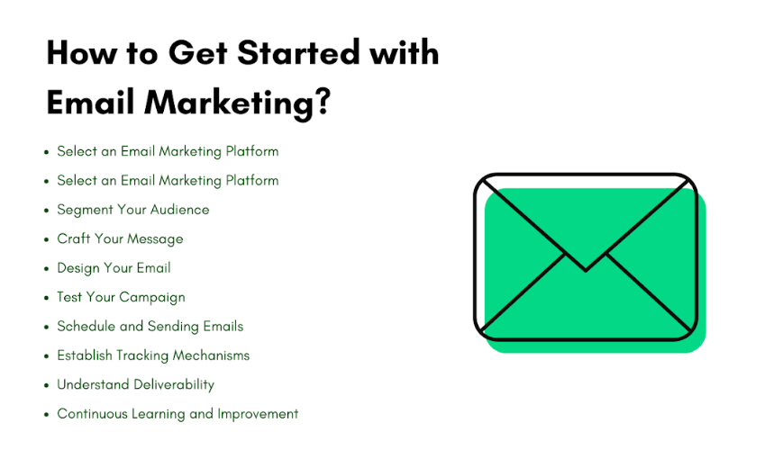

Select an Email Marketing Platform:
The first thing that concerns all participants in email marketing is the selection of the platform. This is because all your subsequent email marketing campaigns depend on it. Most of the well-known services such as Mailchimp, Constant Contact, and ConvertKit come with features such as templates, automation, and analytics. In the case of selecting the platform, these guidelines had to be considered:
- Universality: The use of the platform should not be very complicated as it will attract users who don’t have a deep understanding of programming.
- Features: The right platform always has features of Automation, Segmentation capability, and A/B Testing.
- Scalability: It must be scalable so that owners can expand with the business.
- Customer Support: Your selected platform should have the features to deal with your problems efficiently.
- Pricing: This is another aspect that you should consider when selecting an email service provider. Select a platform that suits you financially and offers features that suit your needs.

B. Create Your First Campaign:
Now that you have decided on a platform your journey to create your first campaign is not that difficult. Campaign goals are step one in any successful campaign marketing strategy.
First, you must establish the goals you intend to achieve with your campaign to act as a guide on how the campaign should be structured. Is your goal to have more sales, website visitors, or better lead management? Specific objectives make up your strategy and content development.

Secondly, specify the customers and the type of email campaign that is required including newsletters, promotional, or personal messages. Coming up with a creative and powerful subject line that would justify the message's high open rates.

C. Segment Your Audience
With the help of segmentation, it is possible to start a successful campaign in the realm of email marketing. This way the audience can be split into sub-groups in which they can be approached according to demographic behavior, purchase patterns, etc. This causes more engagement rates and improved conversion ratios for the business that is being positioned.

To segment effectively, it’s wise to look at users’ data to obtain insights into the organization’s clients and their behaviors. Develop a concept that can be used to segment your audience so that you share appropriate messages at an appropriate time.

D. Craft Your Message
Message is the key component of the email since it is the primary reason for sending an e-mail note. Make sure you write a message in an email that speaks to your audience. Also, ensure the right tone has been created in your message to build the right perception of your audience’s needs and challenges. You should write simple, interesting messages that tally with your targeted campaign. When using the buttons, be persuasive to direct the recipient on the next course of action to either purchase a product, attend an event, or read a blog among others.

In addition, ensure that the content is written in one tone and voice with the brand to create a familiar and trustworthy platform.

E. Design Your Email
The appearance of the email you send is key to its effectiveness, not the content of the message. The importance of making the email as appealing to the eyes as possible made a lot of sense when customers' choices depended on it. Make sure the design is appealing and mobile-optimized. Ensure that the uniformity of your brand is observed by using the appropriate colors, fonts as well as logos.

Only use images and graphics when necessary to support the information that you intend to share. It is also important that the layout of your email be a straightforward layout that conveys your ideas effectively.

F. Test Your Campaign
From a broader perspective, it is wise to keep testing your campaign before implementing it to the entire list of subscribers. A/B testing is one of the common online techniques that involves creating two versions of an email that have different subject lines, images, and call-to-action buttons. Also, a spam test needs to be carried out to check whether the email does not go into the spam folder of the recipient.

Through testing, you realize how the masses respond to a particular campaign to help in subsequent campaigns.

G. Schedule and Sending Emails:
The time it takes to send various email campaigns is a key factor that affects its outcome. Ensure you send your emails at the most appropriate time i.e. at the busiest time or certain days of the week. Most emailing services provided are equipped with features that enable the sending of emails at preferred dates and times.

H. Establish Tracking Mechanisms

To increase the results of your campaigns, and evaluate whether your campaigns are successful or not. Analyze your email marketing tool so that you can be able to monitor the traffic and the response rate of messages sent.

Here, the CTAs should be separated with their trackable links to track their performance individually. The use of such data will enable you to have a clear insight into what should be done in the next campaigns and what should not be done.

I. Understand Deliverability
The deliverability of campaigns is important so your message gets into your recipient’s inbox. In terms of increasing deliverability, the best practice is to ensure that the list was collected by consent and frequently purged from bad practices. It is important not to use spamming words or too many hyperlinks in your emails due to spam checks.

To have a good sender reputation, send emails frequently and do not send emails under any blacklist. It is also important that you constantly check on your sender score in your email platform and deal with all issues on the same.

J. Continuous Learning and Improvement
Current trends and best practices for today’s email marketing are very appropriate given the ever-changing nature of this strategy. Firstly, the information should be continually renewed and tested, which allows the further contests to also be fresh and effective.

Work with managers of other companies, read blogs, attend webinars, and discuss experience in forums to get insights from other marketers. Based on the campaigns you have done, be in a position to determine areas that you will need to improve on and experiment with new ways of increasing your returns.

How to Send Marketing Emails:
Let’s look at the basic elements of marketing emails, various approaches to personalizing such emails, and how you can automate your marketing emails for better efficiency.
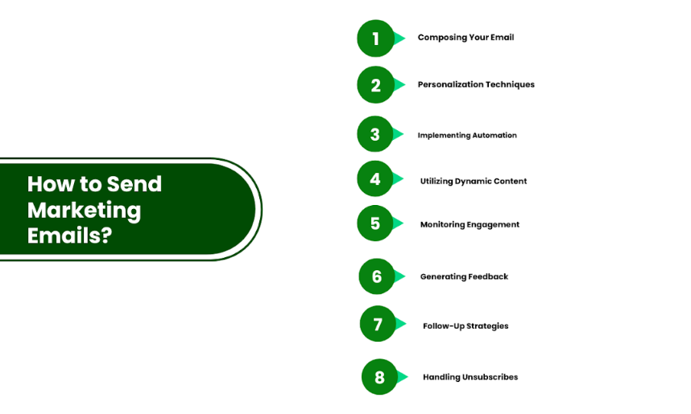

A. Composing Your Email:
Business communication involves letter writing, which should be honestly reinforcing, and brief when it comes to tackling a formal email body. The following are the steps to follow when writing an email:
- Firstly, the subject line should be engaging to ensure that it generates interest and prospects’ responses by opening the email.
- Ensure that all the content is inclusive of the most relevant information and that it contains several CTAs.
- Put all the tips under bullet points or short paragraphs in their effective usage to make it easier to read.
- Make sure that your tone matches that of your brand if you are portraying your brand as professional, friendly, or innovative.

B. Personalization Techniques
Personalization gives high results in terms of its effects on open rates and the level of audience engagement. It would be even better if the recipient’s name is incorporated in the salutation of the email, as it makes emails seem more particular and relevant. It is also advantageous to go beyond the name and provide more personalized content by targeting such attributes as their purchasing history habits, etc, to get better click rates.

C. Implementing Automation
Email campaigns are very effective as they ease the chore of emailing the appropriate message at the correct time to your list. Automation tools can take care of activities such as scheduling, segmentation, and tracking which will enable you to work more on strategic and content aspects. Applying automation techniques helps establish a constant communication flow, eliminates human factors, and saves time and money.

D. Utilizing Dynamic Content
Alternate content takes into consideration the mode of use and interaction by the receiver of the communicated information. For instance, you might show the user different offers regarding products that has previously visited or ordered. Together, these factors specify the target audience and make the ad more personal.
Dynamic content may involve the use of specific features that are inherent in the email marketing platform. Make sure your email templates contain dynamic parts and thoroughly check them to minimize possible failures. By using the A/B testing technique, you will be in a position to identify the right content variations that would be appropriate for future marketing campaigns.

E. Monitoring Engagement
Measuring the engagement is one of the core vision objectives when it comes to the evaluation of the email campaign. Use tools to track open rates, click-through rates, and conversion rates. It’s also recommended to use separate links for each campaign to receive more detailed information concerning the recipients’ behavior and preferences.

This feature is used to analyze the engagement data and make out patterns or trends from it. Find out which of your email features your recipients seem to be most responsive to and build from there. This feedback should be used to fine-tune the subject lines and the content of the emails as well as the CTAs to enhance their effectiveness and click-through rates.

F. Generating Feedback
Collecting feedback from the audience is always useful to know the kind of feedback the audience has on your work. Include surveys and polls in the emails for opinions to be given regarding content, offers as well as general experience. It assists you in improving your future campaigns to better meet the demands of the customers.

G. Follow-Up Strategies
The follow-up email strategies are very essential because they help carry on the conversation with the audience. Such strategies give you a chance to support your statements, give more information, and appeal to those who have doubts. Prepare a unique set as follow-up emails and provide them in the form of business promotions, tips, or even recommendations.

H. Handling Unsubscribes
The principle of obedience becomes vital as far as the unsubscribe procedure is concerned. Ensure that the recipient can easily opt out of your emails and make this process as clear as possible. Perhaps the most important thing to do is to make sure that any unsubscribe request is honored as soon as possible to avoid legal troubles and to protect your brand’s image.

Email Regulations You Should Know:
Using the opportunities of email marketing, the marketer must follow some rules as well as the rights that protect the consumer. It is important to understand such policies to ensure perfect compliance with legislation which enhances customer confidence. Now, let’s look into some of the most important regulations that every email marketing agency in Dubai and their marketers should acquaint themselves with.

Familiarizing with the RUEC:
In the case of sending commercial emails, their regulation is guided by the RUEC ( Regulations on Unsolicited Electronic Communication) in the United Arab Emirates. This law empowers the recipients to find a way to decline future emails received regularly from a particular marketer besides prohibiting exaggerated subject lines and verifying the authenticity of the sender’s details. Such regulations are quite strict and their violation is punished with the performance of significant fines. Therefore, it is necessary to abide by them.

GDPR and Email Marketing
The GDPR is a monumental regulation within the EU that pertains to how peoples’ data is managed by organizations. To be more specific to email marketers, it is necessary to ask for permission before sending people emails, offering an option to opt-out easily and also having adequate measures in place to protect the data. This suggests that anyone involved in email marketing, particularly for an international company, should take GDPR into account since non-compliance can result in severe fines.

CASL Regulations
Another regulation to note is the CASL of Canada for which the marketing emails directed to the Canadians are applicable. Electronic messages such as e-mails, faxes, and other similar text-based messages to their recipients are subject to CASL if they contain a commercial nature and must include certain elements which include the identification of the sender and the recipient. It also provides very limiting standards of the content that is sent as promos which does make it critical for marketers in the business to ensure that they have updated information regarding this issue.

Email Consent and Opt-ins
Consent is the gateway to email marketing compliance. We know that to adhere to GDPR, CASL, or CAN-SPAM, it is mandatory that the consent of the recipients be sought before being emailed. The common way is to apply double opt-in methods, which means that subscribers are then asked to reply to a confirmation email.

Record-Keeping Requirements
It can be recommended that records of all the activities must have been kept accurate. There are several things that marketers need to retain for records, the consent whether in written or through affirmative ticking, opt-out requests, and information about sending emails. This not only serves the purpose of auditing but can also be used in the improvement of marketing plans based on past occurrences.

Privacy Policies:
It is important for any party to ensure that all users are well informed when it comes to the aspects of the privacy policy. It should explain how the subscriber’s information is obtained, processed, and secured. It is very important to update this policy frequently and ensure that it is up to par with the set regulations to build trust and avert legal matters.

Responding to Legal Challenges:
Still, on some occasions, you can experience legal issues. Make certain you should be armed with documents of its compliance and have strategies for addressing complaints. When dealing with various cases it is wise to seek advice from a legal practitioner as this will ensure appropriate handling and solving of the problem.

Conclusion
Finally, you have to understand different strategies and aspects related to email marketing strategies along with how to execute those strategies effectively. The proper realization and compliance with the rules of emailing provide an opportunity not only to deal with legal issues but also to build a reliable relationship with the subscribers.

Do not forget that all the campaigns that you will launch must be as effective as your ability to change and progress. To learn more about email marketing services in Dubai, you are welcome to visit Three Angle Marketing and get more valuable information.

